Name – Harshad Khedekar
Email – harshadkhedekar123@gmail.com

1. To use the ribbon commands, what menu and grouping of commands will you find the Insert and Delete command?
- Home → Cells
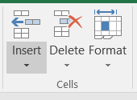

2. If you set a row height or column width to 0 (zero), what happens to the row and column?
- It will disappear [Hidden]
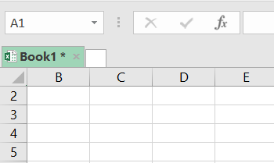
3. Is there a need to change the height and width in a cell? Why?
- Yes, It is necessary to change width and height in excel to ‘fit the data’.
- Excel by default provide equal width and height with respect to columns and rows.
- Whenever we enter a lengthy data, few characters will get displayed and other will be present inside the cell but will be hidden to the user.

4. What is the keyboard shortcut to unhide rows?
- Unhide all rows and columns by using control + A to select the entire worksheet, and then using Control + Shift + 0, or Control + Shift + 9, or both.
- Also, remember that you can use Select Special to make more complicated selections before you hide.
- For example, to hide all rows that contain the divide by zero error in this table, I can use select special to select the errors, then Control + 9 to hide the rows

5. How to hide rows containing blank cells?
To hide rows that contain any blank cells, proceed with these steps:
- Select the range that contains empty cells you want to hide.
- On the Home tab, in the Editing group, click Find & Select > Go To Special.
- In the Go To Special dialog box, select the Blanks radio button, and click OK. This will select all empty cells in the range.
- Press Ctrl + 9 to hide the corresponding rows.
This method works well when you want to hide all rows that contain at least one blank cell, as shown in the below:
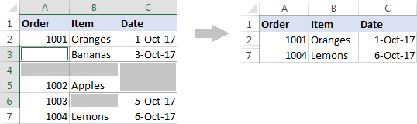
If you want to hide blank rows in Excel, i.e. the rows where all cells are blank, then use the COUNTBLANK formula explained in How to remove blank rows to identify such rows.

6. What are the steps to hide the duplicate values using conditional formatting in excel?
In Excel, there are several ways to filter for unique values—or remove duplicate values:
- To filter for unique values, click Data > Sort & Filter > Advanced.
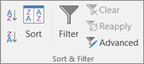
- To remove duplicate values, click Data > Data Tools > Remove Duplicates.
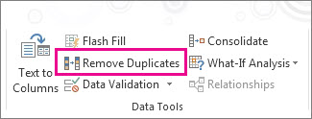
- To highlight unique or duplicate values, use the Conditional Formatting command in the Style group on the Home tab.

